Lab 7.2 Add a node in Nagios Monitoring Tool

This section will show you how to add a node in Nagios Monitoring tool.

This lab has 2 sub-sections:

* + 1. Find the required plugin
    2. Install the plugin and check if it is working

**Step 7.2.1:** Find the required plugin

Go to root directory using the following command.

sudo -i

Create a downloads folder and download Nagios tar file in it.



Extract the file.

tar -zxvf nagios-plugins-2.0.3.tar.gz

Then, navigate to the downloaded folder.

cd nagios-plugins-2.0.3

./configure --with-nagios-user=nagios --with-nagios-group=nagios

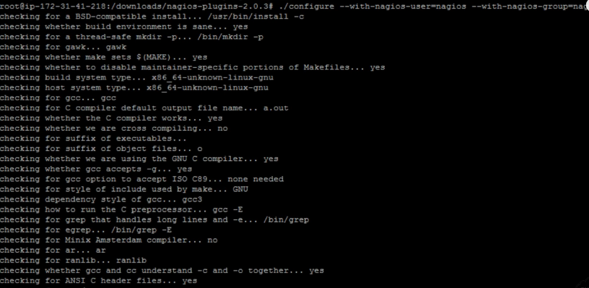

Compile and install the Nagios plugins using the commands below:

make

make install

**Step 7.2.2:** Install the plugin and check if it is working

Restart the Nagios server using the command below:

sudo service nagios restart

Execute the command below to test Nagios|CMP plugin

/usr/local/nagios/libexec/check_icmp 8.8.8.8

The Nagios plugin has been installed successfully.

Open the browser and login to your nagios account.

Wait for 5 minutes and click on the services option to check if the plugins are working now.